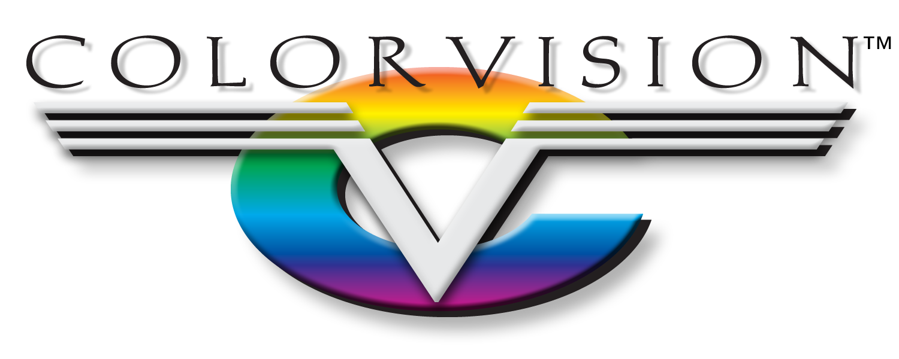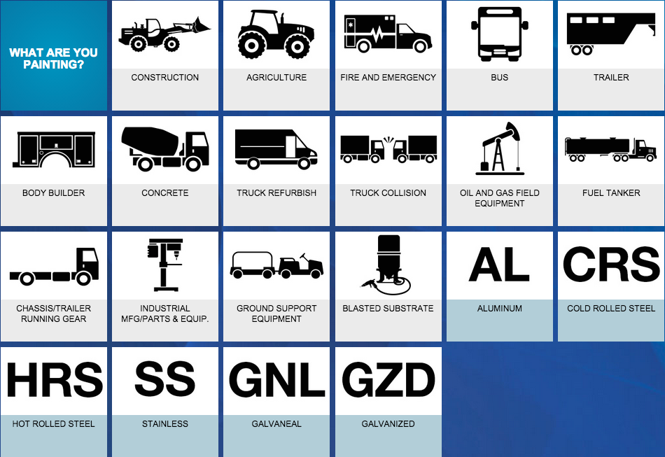

Productivity. Profitability. Partnership.

Everyday, we live by our core business principles: ‘Honesty & Integrity Above All Things, Be Proactive With Everything, and Don’t Tell Me No, Tell Me How.’ Our business principles, coupled with our extensive knowledge of manufacturing operations, makes us a great partner for you. Our number one concern is always your success, as ours depends on it. At any time, we would like to sit down with you and discuss how a partnership with ColorVision can be a benefit to us both.

**Partnership** With ColorVision

MO Springfield West Plains Independence KS Lenexa Lawrence

Profitability

When manufacturing products, quality can be the end user's deciding factor to choose you over your competition. When your products are finished with an appealing, sustainable coating, that can reflect the quality in every part you produce and, in turn, you sell more units and make more money. Using our Commercial System Selector, you can ensure that you start every project on the right foot. Simply select the product you are working on, filter down the types of products you need, then select from a wide variety of systems to fit your need. We have an economy topcoat offering in ALK100 to a premium line of AUE300/360/370. From there, you can expect fast application & cure times, pushing more units to your clients, increasing your profits.