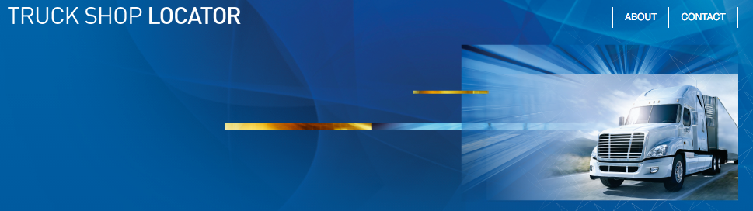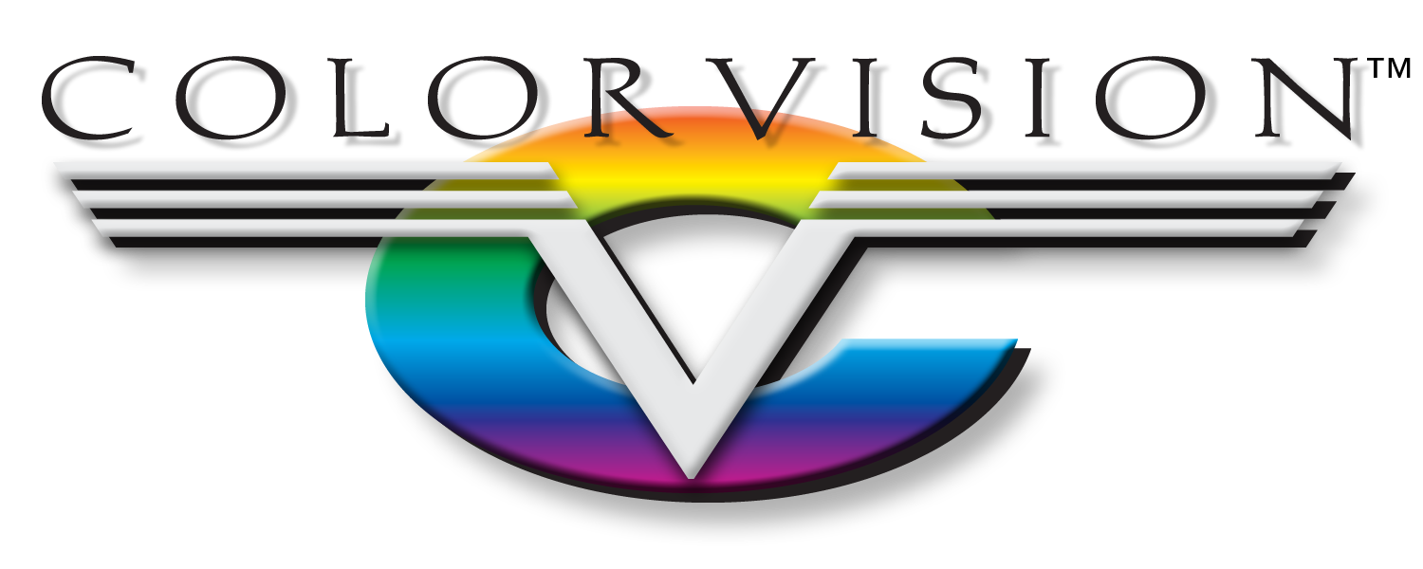

Productivity. Profitability. Partnership.

Profitability

One of our top priorities is to ensure your success by helping to increase your profits. We help you to manage this in many ways but one standout program is the AdjustRite Commercial Estimating System. AdjustRite is a full-service application that takes into consideration the overall commercial truck claim process including assignment dispatch, image uploading, total loss evaluations, claim file notations, invoices, management reports, and more. AdjustRite’s most unique feature is the use of the actual truck model information. This technology makes the system capable of producing accurate appraisals based on an advanced database compiled from truck parts and repair data. The system’s procedural logic and automated features makes the claim process faster and easier, allowing you to process more work, and make more bottom line dollars.

Another high-value profitability advantage with ColorVision & PPG is the Truck Shop Locator program. Potential customers can search for a truck shop in their area and can easily be directed straight to you. It’s free to PPG Truck Shops and the marketing potential is endless.

Everyday, we live by our core business principles: ‘Honesty & Integrity Above All Things, Be Proactive With Everything, and Don’t Tell Me No, Tell Me How.’ Our business principles, coupled with our extensive knowledge of collision center operations, makes us a great partner for you. Our number one concern is always your success, as ours depends on it. At any time, we would like to sit down with you and discuss how a partnership with ColorVision can be a benefit to us both.

**Partnership** With ColorVision

MO Springfield West Plains Independence KS Lenexa Lawrence