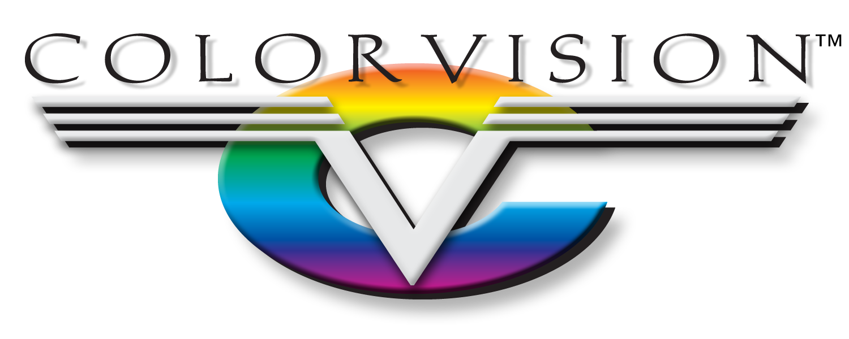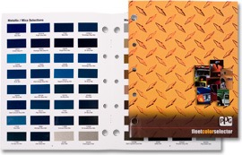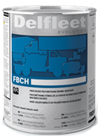

The

ColorVision Culture

The driving force behind ColorVision is the belief that ‘Our Success Depends on Yours.’ Our toolbox contains Business Development Managers to increase profitability in the office, Certified Technical Representatives to boost productivity in the shop, and Store Personnel to ensure that you receive your orders on time, every time. While paint is our passion, we differentiate ourselves by being the best at understanding how commercial truck repair centers operate, top-to-bottom. We are a cohesive team, working as one, to form a long-lasting partnership with you.

Productivity. Profitability. Partnership.

MO Springfield West Plains Independence KS Lenexa Lawrence

Productivity

Productivity encompasses every aspect of the shop, from a well written estimate, to speed and performance in the paint shop. Our business teams can advise the office how to get the job started right and our technical teams can ensure that the right products and processes are in place in the shop to move each repair through your facility at maximum efficiency. The Delfleet Evolution System from PPG is quickly becoming the new standard for high-caliber truck repair centers. Delfleet is matched to OEM standards, variants, & alternates giving you the peace of mind that the truck will look fresh from the factory, every time.