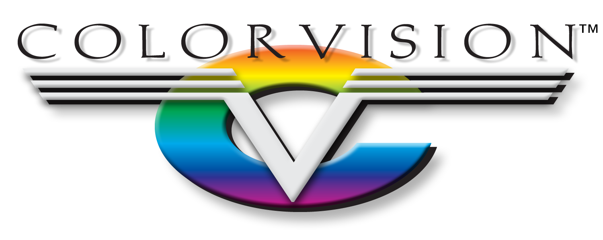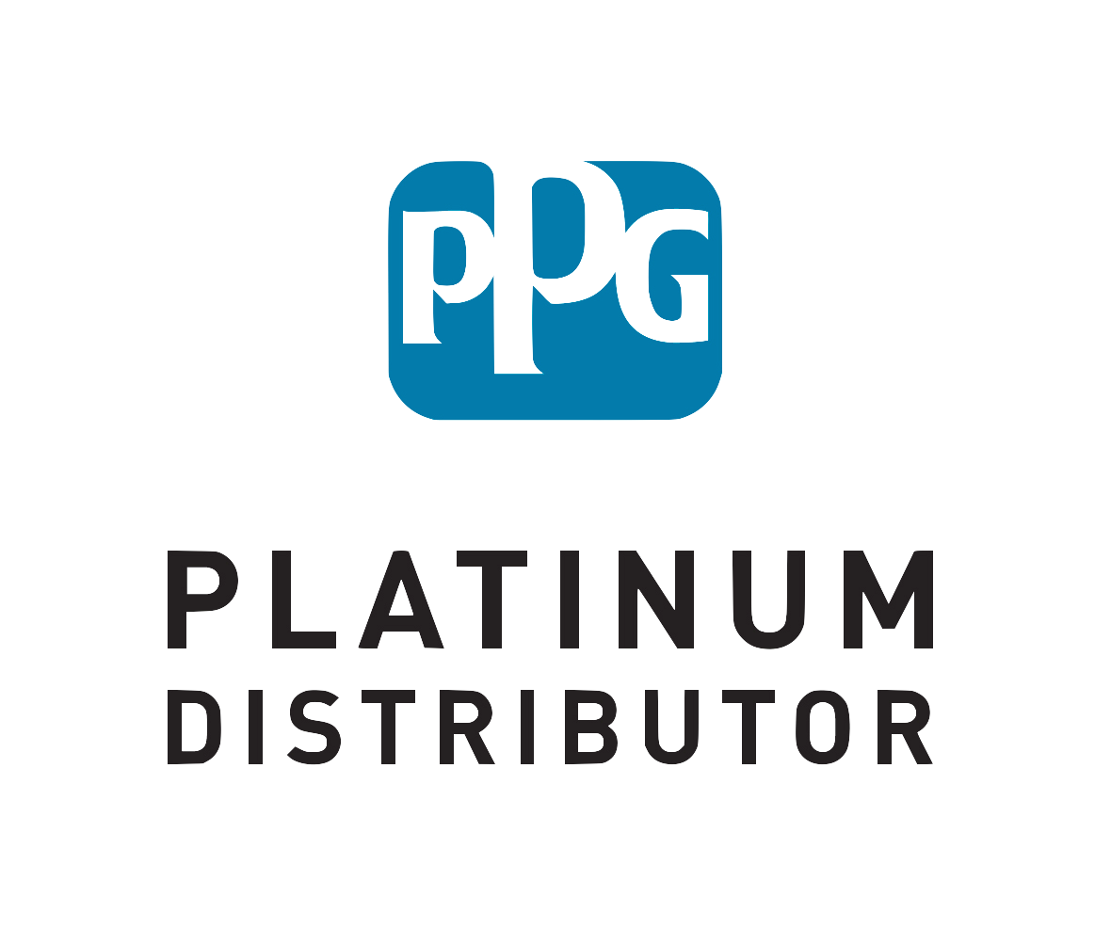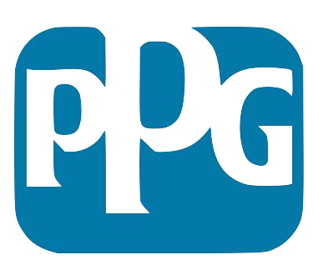

MO Springfield West Plains Independence KS Lenexa Lawrence

I. Introductions

Interview Meeting Agenda

II. ColorVision Overview

IV. Needs Assessment

V. What’s Next?

The

ColorVision Culture

The driving force behind ColorVision is the belief that ‘Our Success Depends on Yours.’ Our toolbox contains Business Development Managers to increase profitability in the office, Certified Technical Representatives to boost productivity in the shop, and Store Personnel to ensure that you receive your orders on time, every time. While paint is our passion, we differentiate ourselves by being the best at understanding how collision centers operate, top-to-bottom. We are a cohesive team, working as one, to form a long-lasting partnership with you.

III. COLLISION CENTER NAME Overview