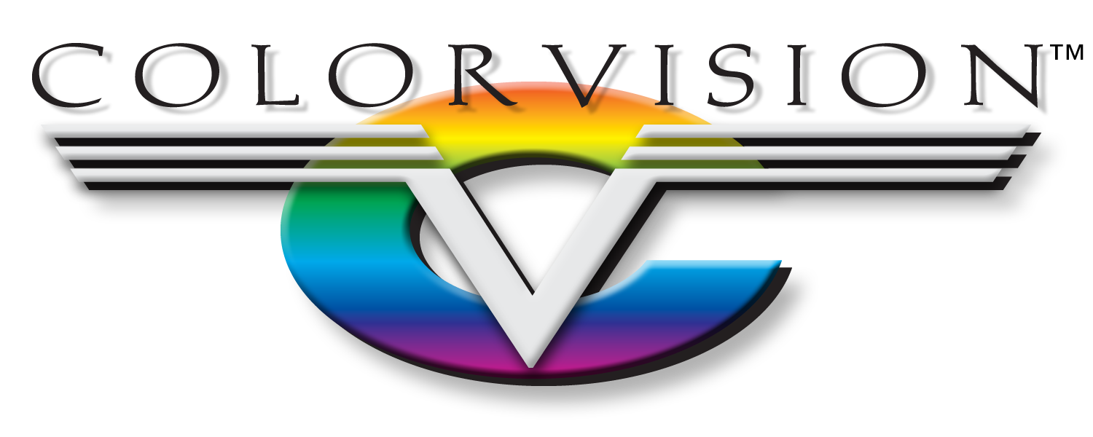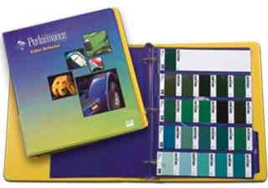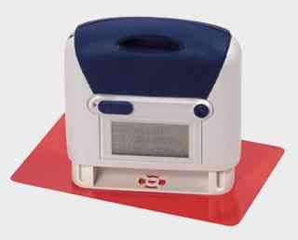

The driving force behind ColorVision is the belief that ‘Our Success Depends on Yours.’ Our toolbox contains Business Development Managers to increase profitability in the office, Certified Technical Representatives to boost productivity in the shop, and Store Personnel to ensure that you receive your orders on time, every time. While paint is our passion, we differentiate ourselves by being the best at understanding how manufacturers operate, top-to-bottom. We are a cohesive team, working as one, to form a long-lasting partnership with you.

The

ColorVision Culture

Productivity. Profitability. Partnership.

MO Springfield West Plains Independence KS Lenexa Lawrence

Productivity

We understand one of the most crucial factors to success in a manufacturing environment is productivity. Our products and processes are built to fit that need. To start the coating application process, we can match client-specified colors with our Color Identifier Tool. The tool allows you to quickly check a target substrate color then match it to a chip in our CPC Color Selector book. Once a color is selected, one of our Commercial Performance Coatings can be selected. AUE370 DTM is built to maximize production. With the capability to go direct to metal, there is no wasted time between fabrication and coating application. With AUE370 you have to power to apply with an airless spray system and AUE40 OEM Clearcoat can be applied for a crystal clear, high-gloss finish. We know your needs, and are here to exceed all of them.