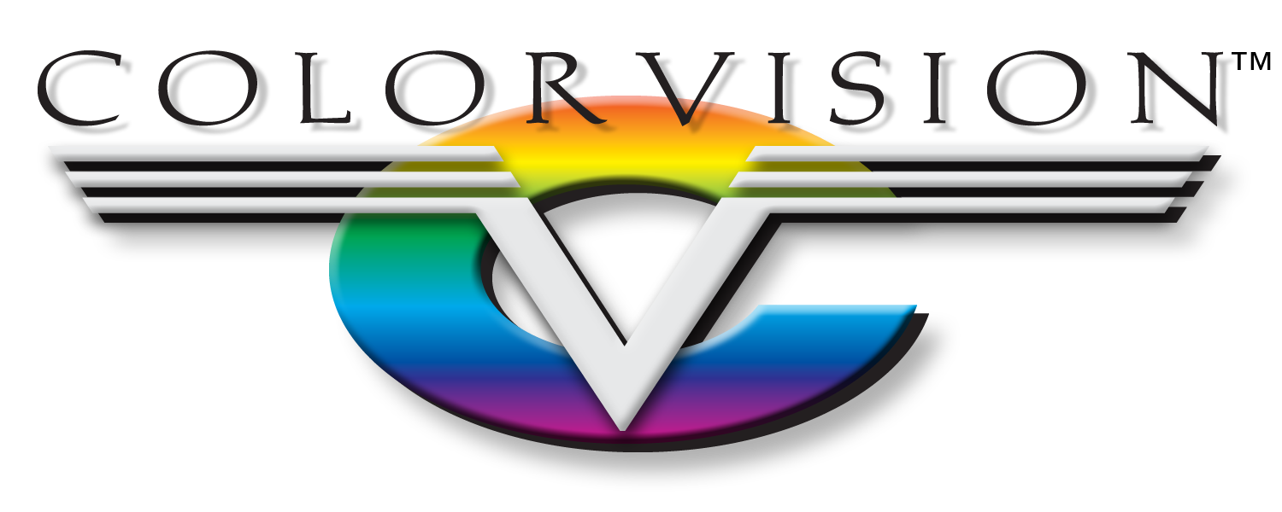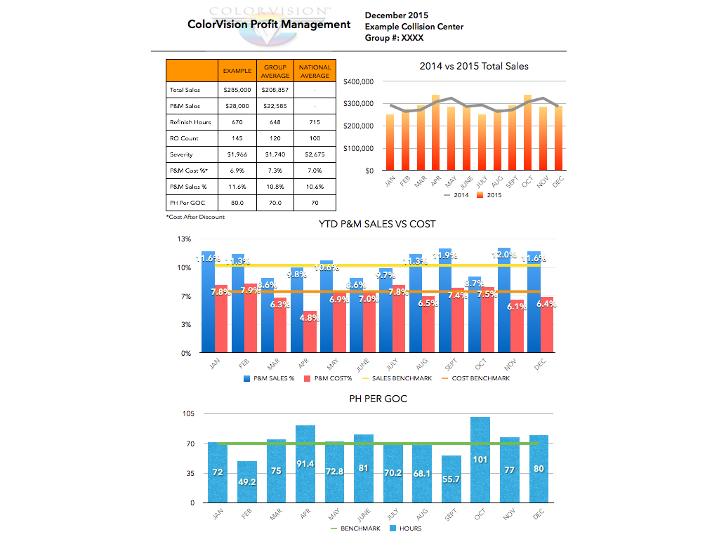

MO Springfield West Plains Independence KS Lenexa Lawrence

Productivity. Profitability. Partnership.

Profitability

One of our top priorities is to ensure your success by helping to increase your profits. We help you to manage this in many ways but a couple standout programs are ColorVision Profit Management and our Account Maintenance Matrix. ColorVision Profit Management -or CPM- is designed to help you ask the right questions. We receive four, simple numbers from you every month and in exchange, you get a report detailing how you are performing on seven different metrics, against other facilities in your area. With this knowledge, we can highlight areas of strength and help you focus on areas that need improvement. The Account Maintenance Matrix is a bi-annual audit performed by our technical teams that gives you the confidence that your paint shop is running at full capacity. Product waste, re-do’s, & color match are all areas that can slow the paint team down, costing you bottom-line profits. Our goal is to maximize the paint shop’s performance, thus increasing your profitability.

Everyday, we live by our core business principles: ‘Honesty & Integrity Above All Things, Be Proactive With Everything, and Don’t Tell Me No, Tell Me How.’ Our business principles, coupled with our extensive knowledge of collision center operations, makes us a great partner for you. Our number one concern is always your success, as ours depends on it. At any time, we would like to sit down with you and discuss how a partnership with ColorVision can be a benefit to us both.

**Partnership** With ColorVision